**Diversity Survey Results 2021**

VWV is committed to being an equal opportunities employer.

In order to assess our effectiveness, we monitor diversity in the firm. Our most recent diversity surveys were carried out in line with the SRA's requirements and include questions about socio-economic background and caring responsibilities. All staff and partners had the opportunity to complete the survey, although participation was voluntary.

We are publishing these summary results to ensure that no individuals can be identified.

**Role in the Firm**

Select one category which best describes your role in the firm

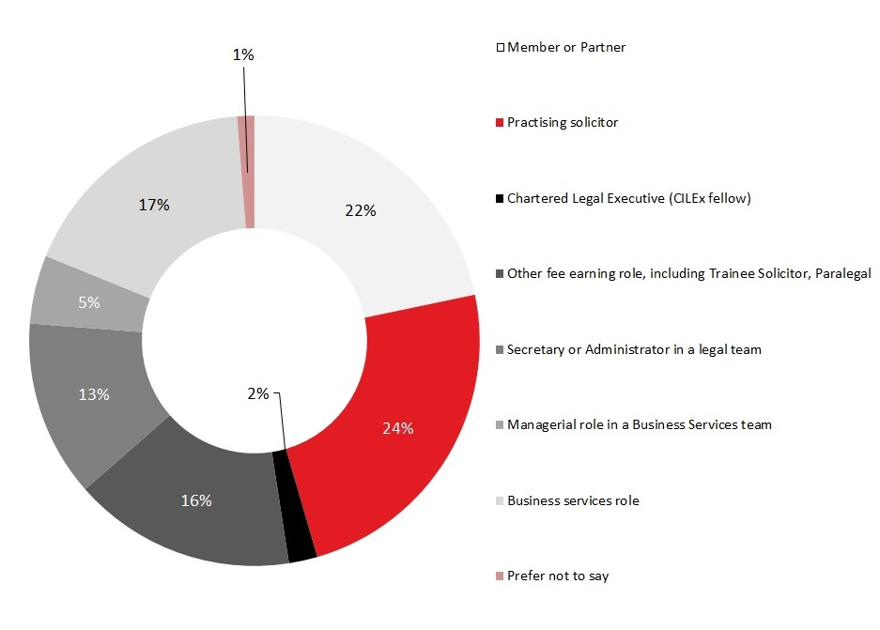

**Age Distribution**

Which age category are you in?

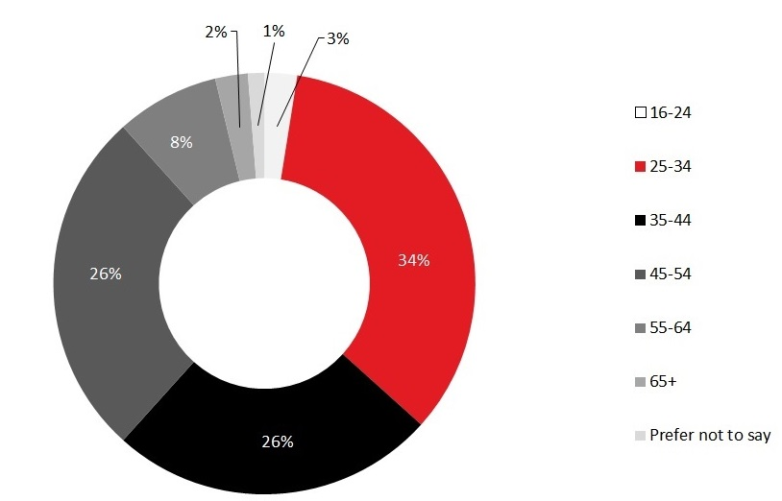

**Gender**

Which gender do you identify with?

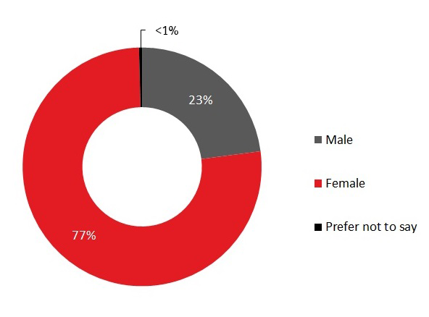

Is the gender you identify with the same as your sex registered at birth?

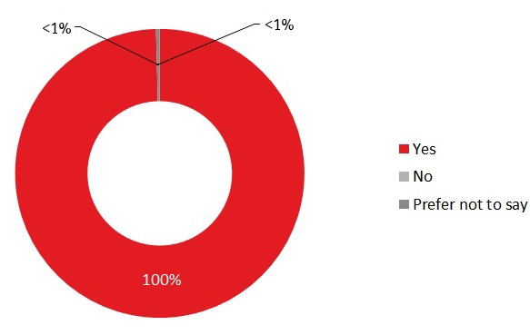

**Disability**

Do you consider yourself to have a disability according to the definition in the Equality Act 2010?

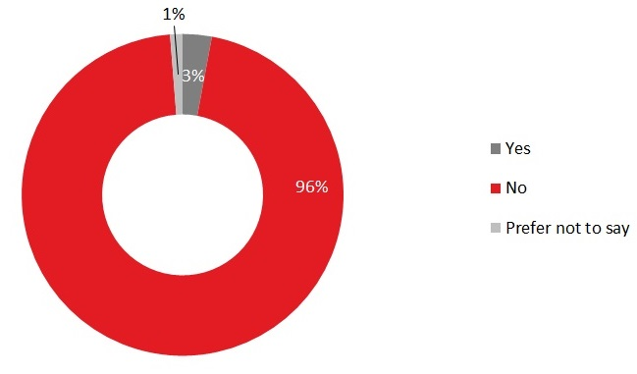

Are your day-to-day activities limited because of a health problem or disability which has lasted, or is expected to last, at least 12 months?

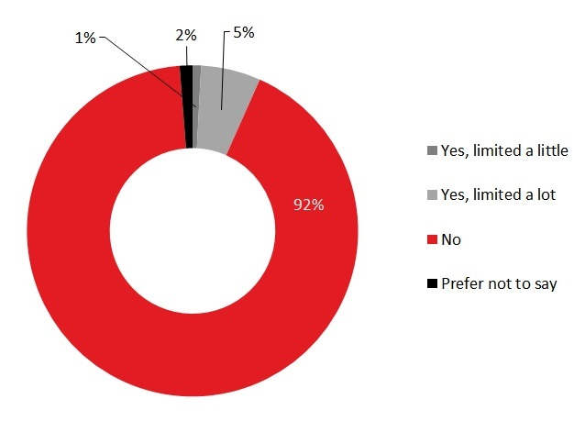

**Ethnic Group**

What is your ethnic group?

|  |  |
| --- | --- |
| Asian / Asian British: Bangladeshi | 0.42% |
| Asian / Asian British: Chinese | 0.83% |
| Asian / Asian British: Indian | 2.08% |
| Asian / Asian British: Pakistani | 0.42% |
| Asian / Asian British: Any other Asian background | 0.83% |
| Black / Black British: African | 0.83% |
| Black / Black British: Caribbean | 2.92% |
| Black / Black British: Any other Black background | 0.00% |
| Mixed / multiple ethnic groups: White and Asian | 0.42% |
| Mixed / multiple ethnic groups: White and Black African | 0.42% |
| Mixed / multiple ethnic groups: White and Black Caribbean | 0.83% |
| Mixed / multiple ethnic groups: Any other mixed / multiple ethnic background | 0.83% |
| White: British / English / Welsh / Northern Irish / Scottish | 78.75% |
| White: Irish | 0.83% |
| White: Gypsy or Irish Traveller | 0.00% |
| White: Roma | 0.00% |
| White: Any other White background | 6.25% |
| Other ethnic group: Arab | 0.42% |
| Other ethnic group: Any other ethnic group | 0.42% |
| Prefer not to say | 2.50% |

**Religion or Belief**

What is your religion or belief?

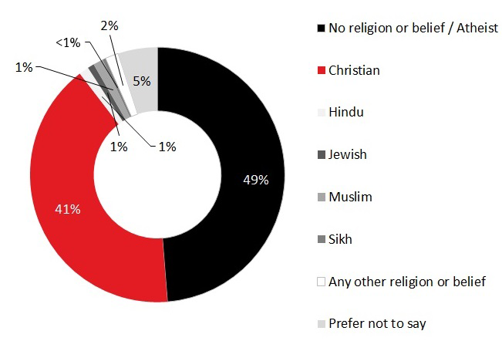

**Sexual Orientation**

What is your sexual orientation?

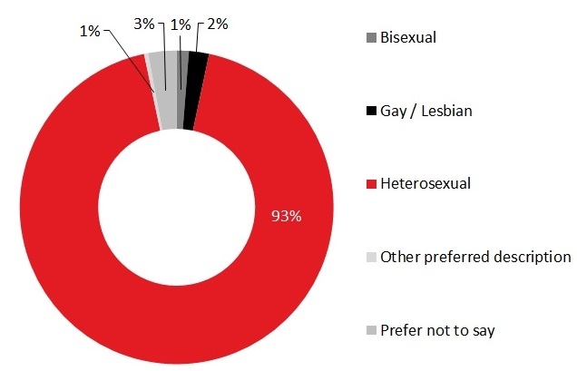

**Secondary School Background**

What type of school did you attend for most time between the ages of 11 and 16?

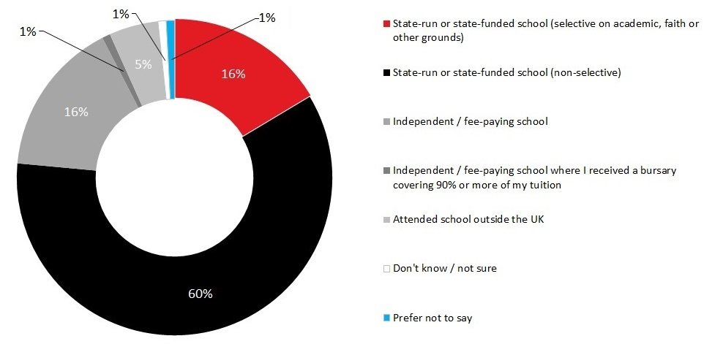

**Parental Qualifications**

Did either of your parents attend university by the time you were 18?

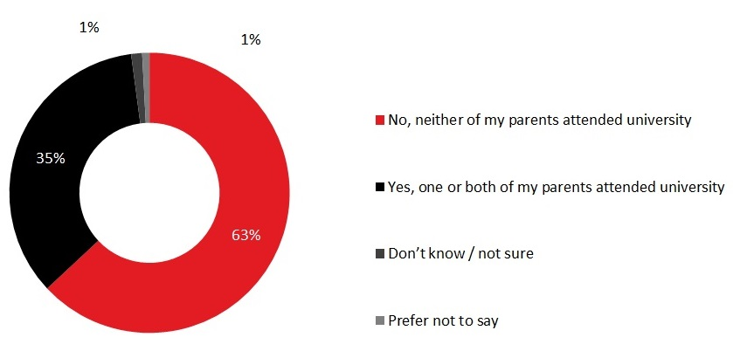

**Socio-Economic Background**

What was the occupation of your main household earner when you were about 14?

|  |  |
| --- | --- |
| Modern professional and traditional professional occupations such as: teacher, nurse, physiotherapist, social worker, musician, police officer (sergeant or above), software designer, accountant, solicitor, medical practitioner, scientist, civil / mechanical engineer. | 40.76% |
| Senior, middle, or junior managers or administrators such as: finance manager, chief executive, large business owner, office manager, retail manager, bank manager, restaurant manager, warehouse manager. | 20.59% |
| Clerical and intermediate occupations such as: secretary, personal assistant, call centre agent, clerical worker, nursery nurse. | 5.46% |
| Technical and craft occupations such as: motor mechanic, plumber, printer, electrician, gardener, train driver. | 10.92% |
| Routine, semi-routine, manual, and service occupations such as: postal worker, machine operative, security guard, caretaker, farm worker, catering assistant, sales assistant, HGV driver, cleaner, porter, packer, labourer, waiter/waitress, bar staff. | 8.40% |
| Small business owners who employed less than 25 people such as: corner shop owners, small plumbing companies, retail shop owner, single restaurant or cafe owner, taxi owner, garage owner. | 5.88% |
| Long term unemployed (claimed Jobseeker's Allowance or earlier unemployment benefit for more than a year) | 0.84% |
| Other, such as: retired / this question does not apply to me / I don’t know | 3.36% |
| Prefer not to say | 3.78% |

**Caring Responsibilities**

Are you a primary carer for a child or children under 18?

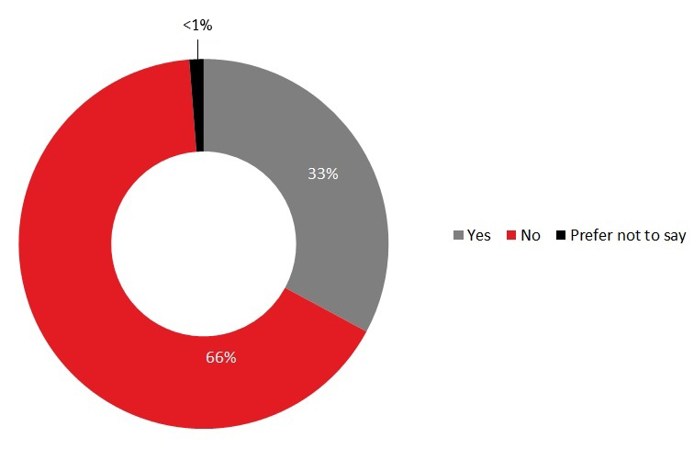

Do you look after or care for someone with long term physical or mental ill health caused by disability or age (not in a paid capacity)?

